Practice Questions

MCQs

What is the maximum possible number of pivots in a 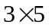 matrix ?

(a) 1
(b) 2
(c) 3
(d) 4

Which of the following is true for the partitioned matrices 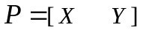 and 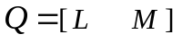, where sub-matrices  and have the same sizes as and  respectively ?

(a) 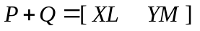
(b) 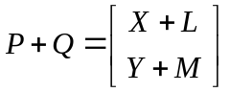
(c) 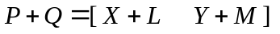
(d) 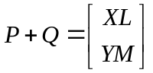

Short

Question No. 1. Show that the following system of linear equations has unique solution :

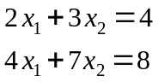

Question No. 2. If a matrix is decomposed into 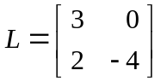 and 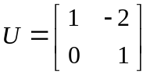 by 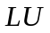 factorization , then find .

Answer 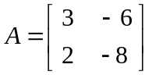

Long
Question No. 3. If 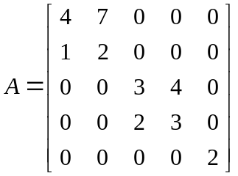 is a block diagonal matrix , then find 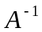 .
Answer 